Southwest Delivery Solutions, INC.  Rates:  (Phoenix Area)  Central Corridor……………..10.00$  8 Miles or Less……………….15.00$  9-14 Miles……………………..18.00$  15 Miles or More…………….20.00$  Rates apply from anywhere in city limits.  Glendale ..……………………..20.00$  Scottsdale/P.V. ..……………20.00$  Tempe ..………………………..20.00$  Peoria .………………………….20.00$  Mesa …………………………….22.00$  Chandler ……………………….25.00$  Gilbert…………………………..25.00$ |  |  | Computer Dispatched  602-266-5577  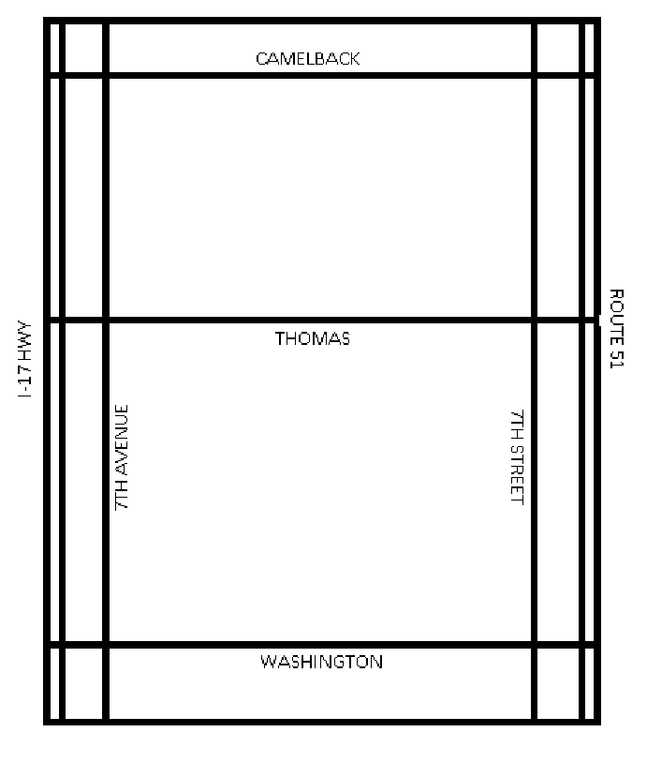  Central Corridor  7thave to 7th St.  Camelback to Washington |  |  | ffffff  *24 Hours A Day Seven Days A Week.  *1 Hour Super Rush 10.00$ Additional Charge.  *We will pick-up & deliver your package, within 1 hour for any delivery 15 miles or less Guarunteed!  602-266-5577

Delivery Services & Pricing Options:  ----------------------------------------------------------------  *1 HOUR SUPER RUSH………..10.00$  *COURT FILING…………………5.00$  *HANDLING OF FUNDS……….5.00$  *EXTRA DELIVERIES…………4.00$  _____________________________  *EXTRA WEIGHT: FIRST 25LBS FREE ADDITIONAL 3.00$ CHARGE FOR EVERY 25LBS  *ATTEMPTED DELIVERY…….50% OF RATE  *WAITING TIME: FIRST 10 MINUTES FREE 5.00$ FOR EACH ADDITIONAL 10 MINUTE BLOCK OF TIME  *DELIVERIES NATIONWIDE  *COMPLETE FACSIMILE & COPY SERVICE  _____________________________ |  |  | Process Service:  SERVICES  *NOTIFICATION OF SERVICE WITHIN 24 HOURS  * WRITTEN PROGRESS REPORRTS  *NATIONAL INVESTIGATIVE CAPABILITIES  *SKIP TRACING  *DMV REPORTS & STAKE OUTS  RATES:  SERVICE (SUMMONS OR SUBPOENA)…15.00$  SERVICE (WRIT)…………………………………..40.00$  MILEAGE FEE (ONE WAY)……………………….2.00$  MINIMUM MILEAGE……………………………….16.00$  STAKE OUT (PER HOUR)……………………….30.00$  SKIP TRACE (PLUS COSTS)……………….….25.00$  RESEARCH (PER HOUR)…………………………30.00$  HANDLING FEE (OUT OF TOWN)…………..30.00$  SCHEDULED DAILY PICKUPS (MONTH).150.00$  RUSH SERVICE……………………………………….20.00$ |  |  | Southwest Delivery Solutions, INC.  PLEASE VISIT OUR WEBSITE AT:  WWW.SOUTHWESTDELIVERYSOULTIONS.COM

